*Assignment*

**Lab 14: Web Design Application – AI-Assisted HTML/CSS/JS Generation**

**Htno :**2503A52L09

**Task 1: AI-Assisted Portfolio Website**  
**Scenario:**  
A student wants to showcase their projects, skills, and contact details in  
a portfolio website. Instead of writing all code manually, they want to  
speed up the process using GitHub Copilot.  
• Use Copilot to generate an HTML structure for a personal  
 portfolio page (sections: Home, About, Projects, Contact).  
• Ask Copilot to suggest responsive CSS styling for the layout  
 (e.g., grid/flexbox).  
• Customize Copilot’s suggestions to add a hover effect on project  
 cards

**Code :**

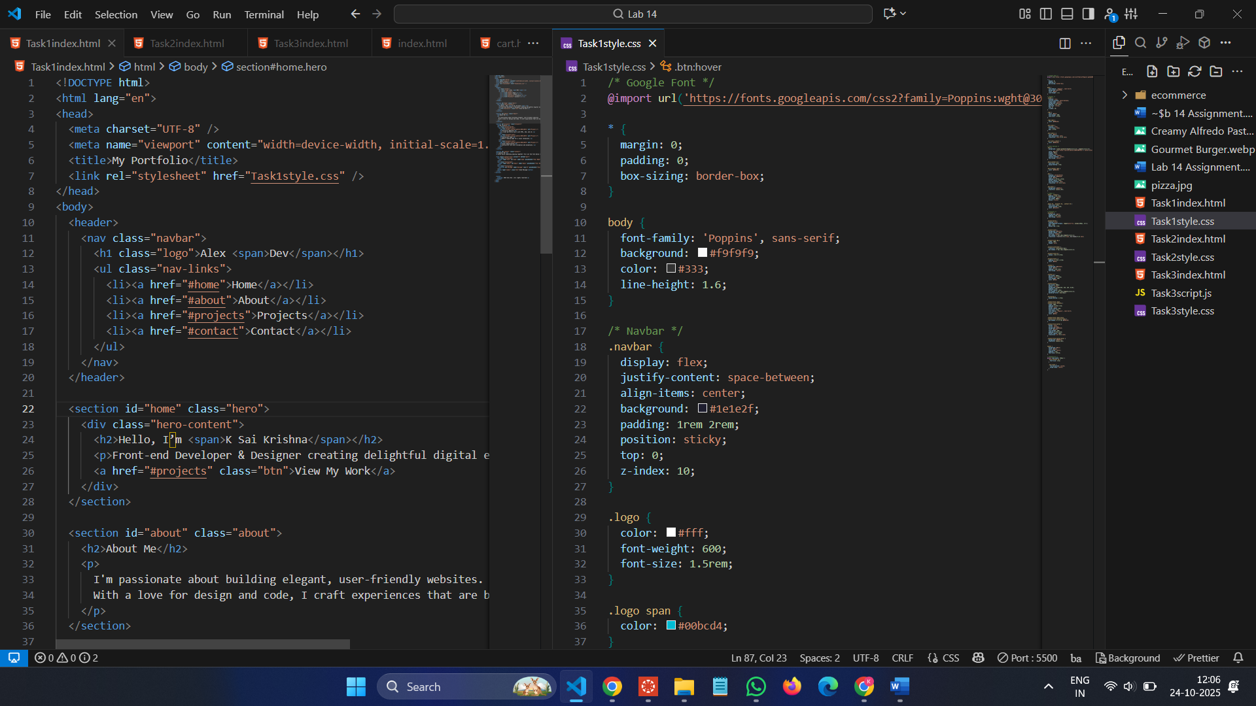

**Output :**

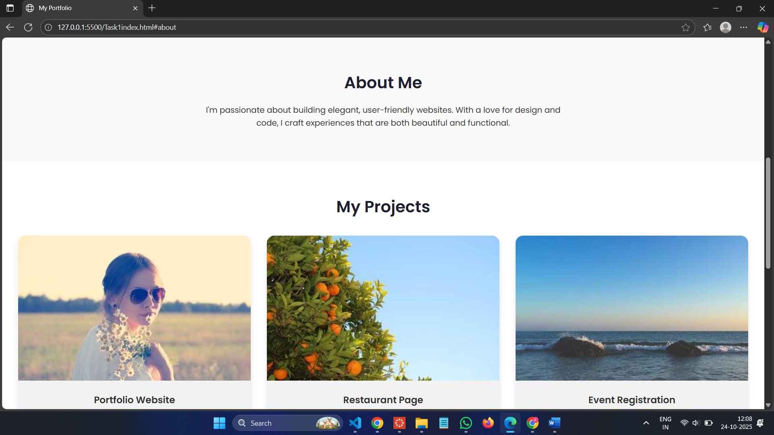

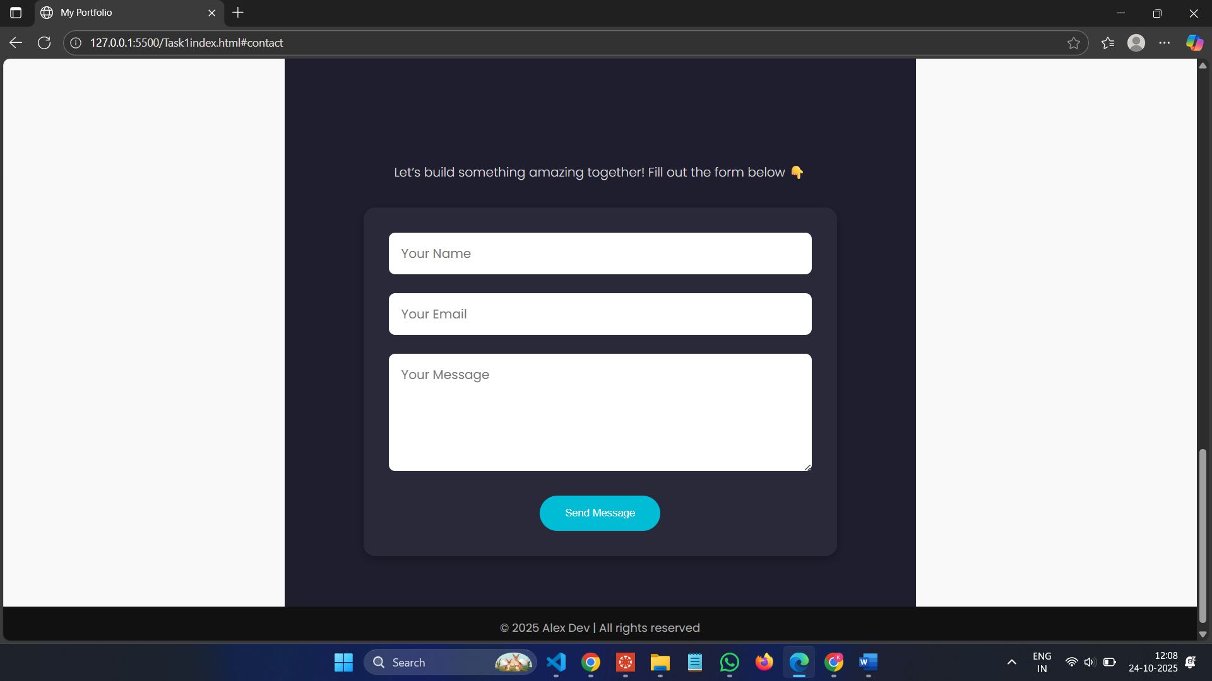

**Task 2: AI-Generated Restaurant Landing Page**  
**Scenario:**  
A local restaurant needs a simple landing page with a navigation bar,  
menu highlights, and an image gallery. The developer wants to quickly  
generate it using AI assistance.  
• Use Copilot to create a navigation bar with links (Home, Menu,  
 Gallery, Contact).  
• Generate a menu section styled with CSS cards.  
• Add a JavaScript-based image slider for the gallery, with  
 Copilot suggesting the base code

**Code :**

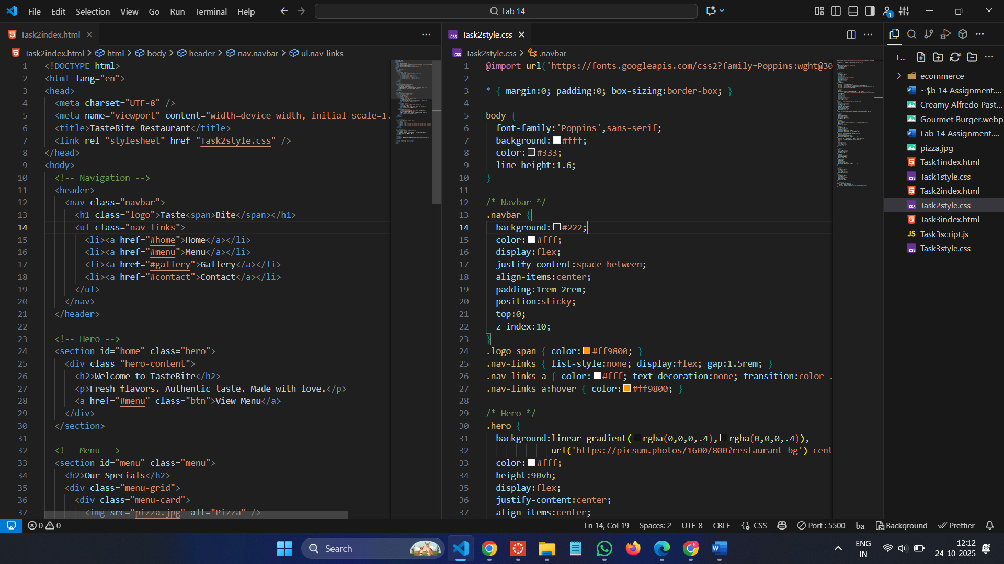

**Output :**

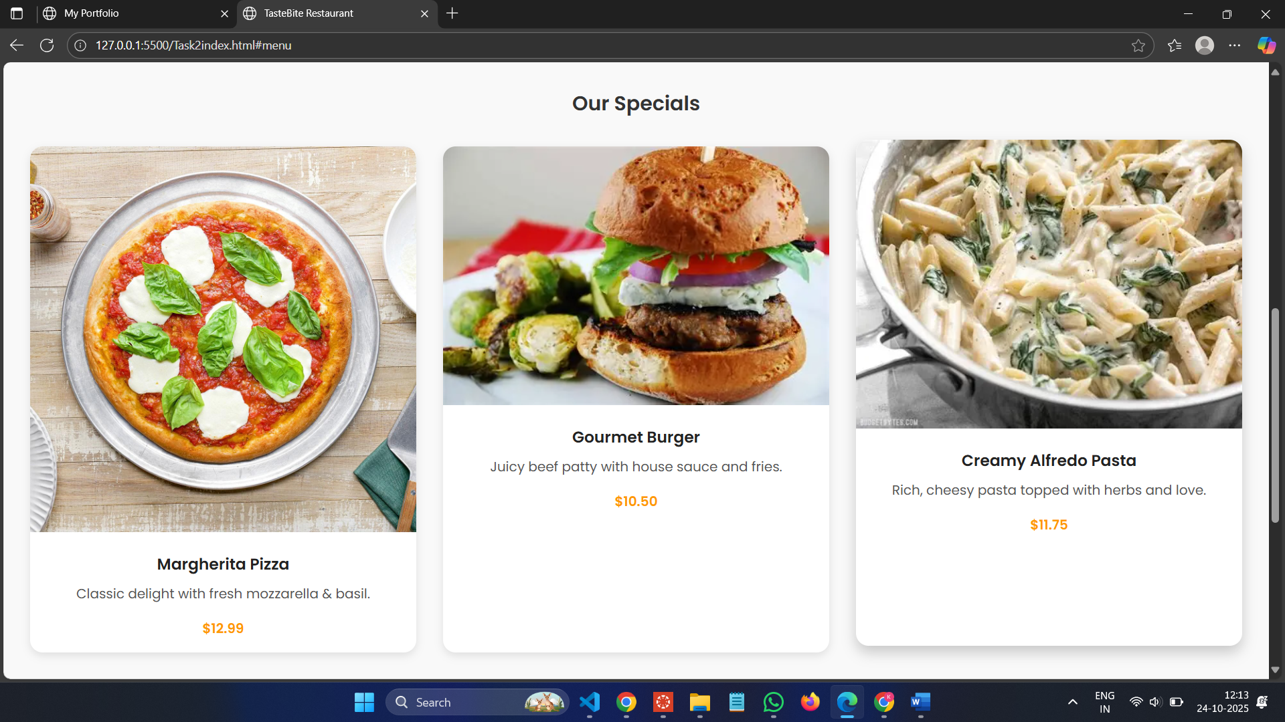

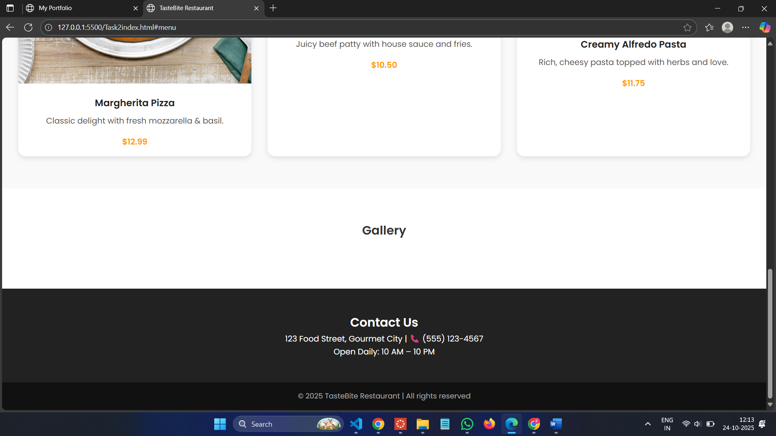

**Task 3: AI-Powered Event Registration Form  
Scenario:**  
SR University is hosting a tech fest. They need a web-based registration  
form for students. The form must validate user input in real-time.  
• Ask Copilot to generate an HTML form (fields: Name, Email,  
 Phone, Department, Event Selection).  
• Use Copilot to assist in adding CSS styling for an attractive form  
 layout.  
• Implement JavaScript validation (e.g., email format check,  
 phone number length check) using Copilot’s suggestions.

**Code :**

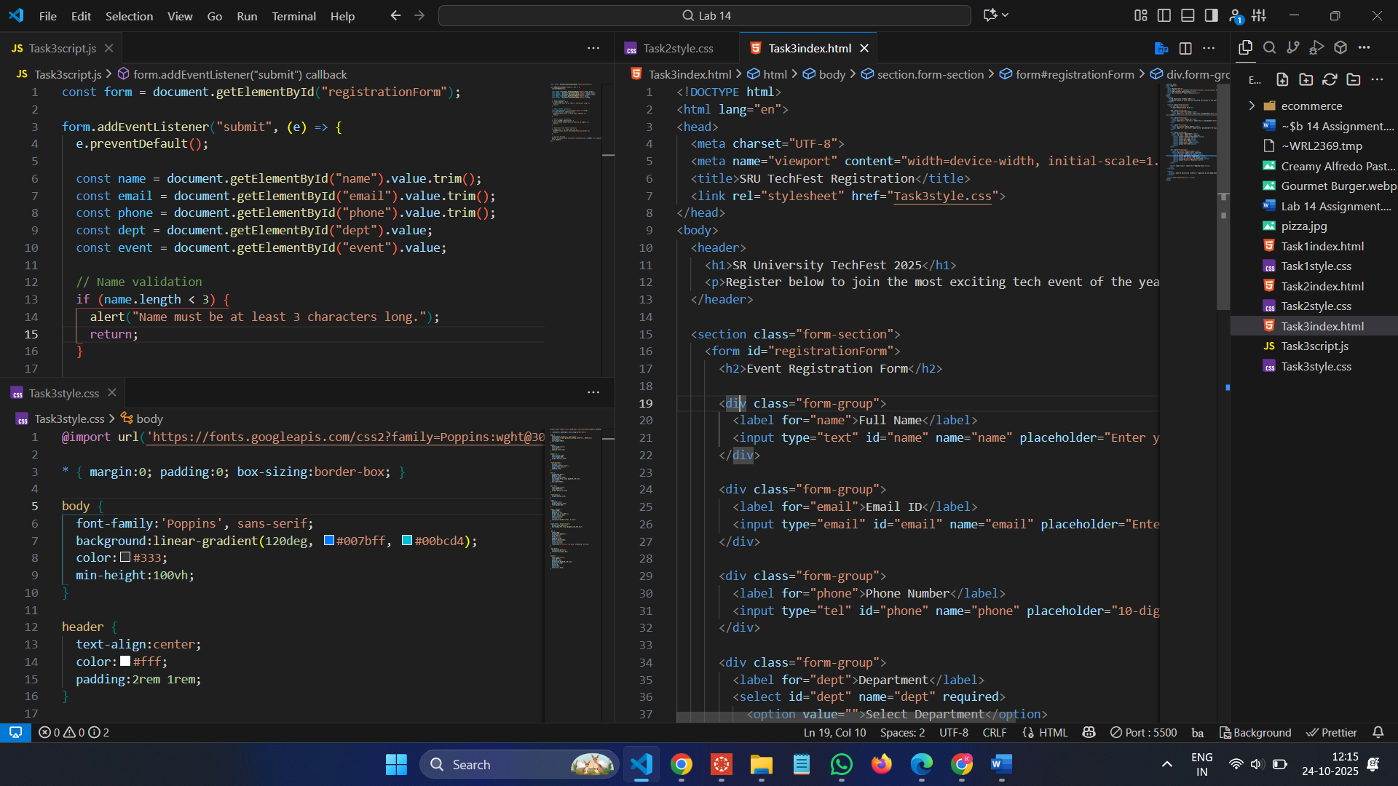

**Output :**

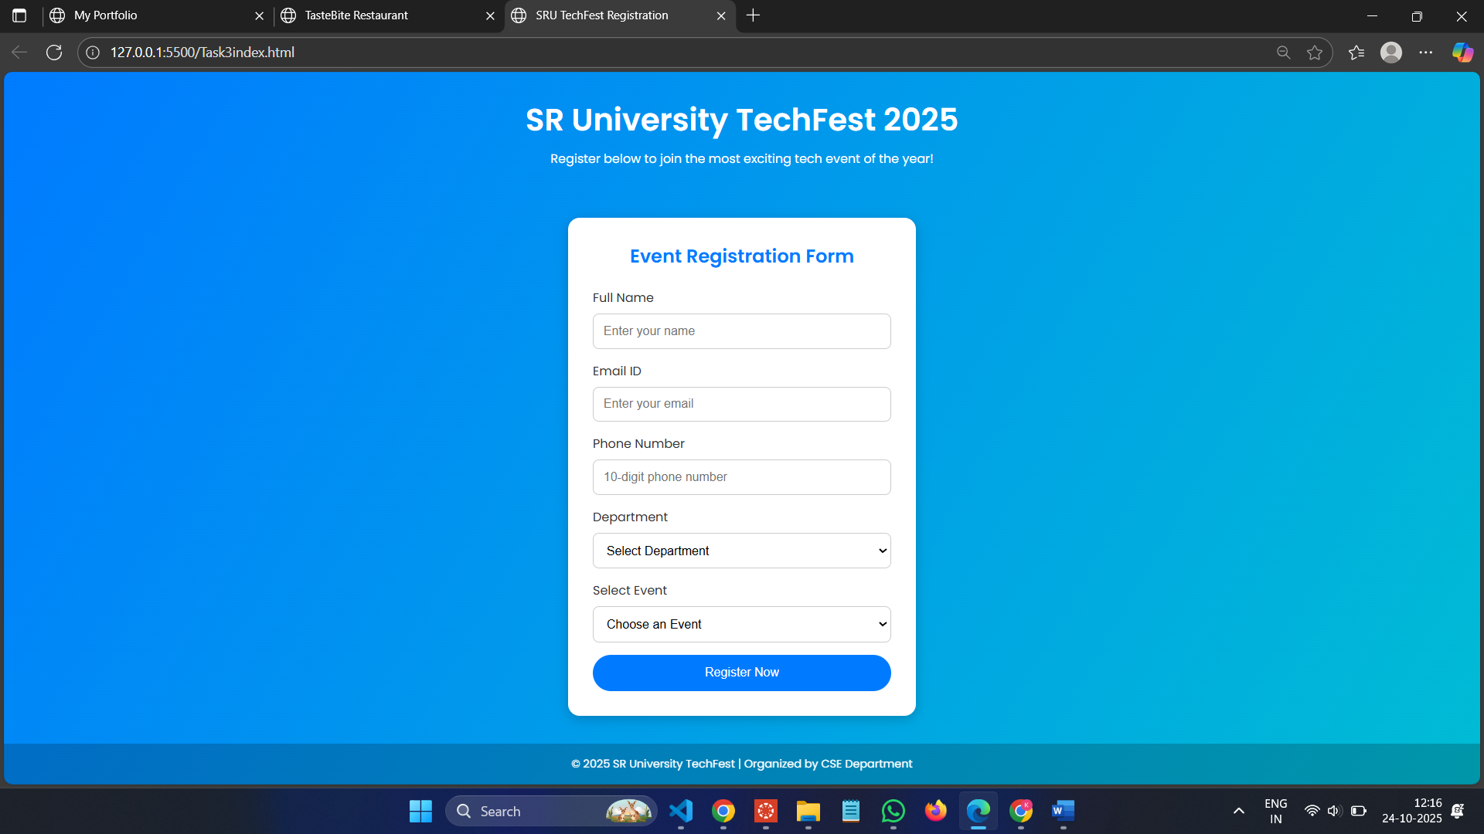

**Task 4: AI-Assisted E-Commerce Product Page**  
**Scenario:**  
A startup wants a basic e-commerce product page to display products  
with prices and an “Add to Cart” button.  
• Use Copilot to generate a grid-based product catalog in  
 HTML/CSS.  
• Implement a JavaScript “Add to Cart” functionality with  
 Copilot’s guidance.  
• Modify Copilot’s suggestions to include a cart counter at the  
 top-right corner of the page.

**Code :**

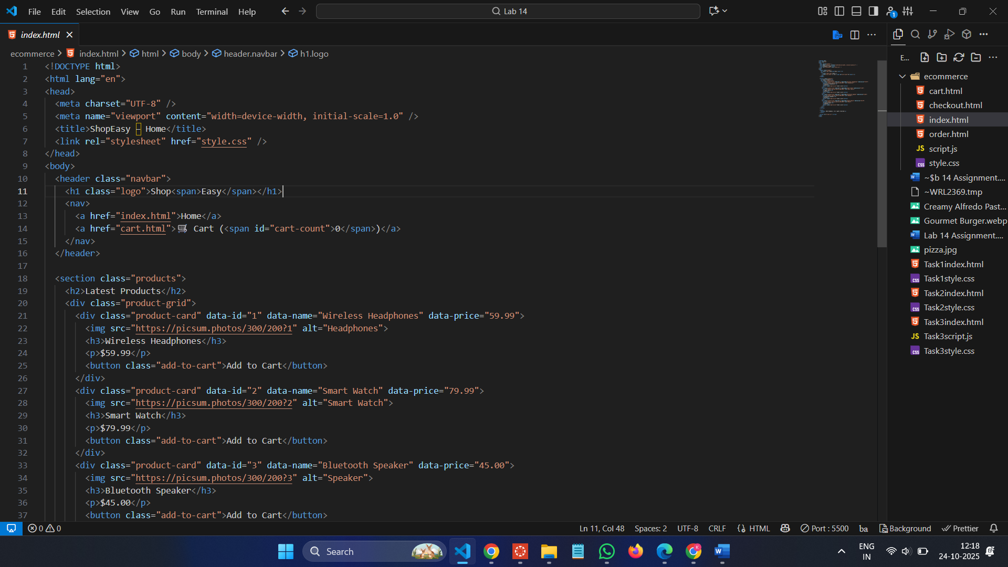

**Output :**

